Programmable Flashlight for senior design
MayFlower
By
Jing Li, Bolin Dai, Yinan Fu, Chengzhang Li

ECE 496C – Senior Design I
December 14, 2014



Project Introduction：
This report is of the product of our senior design for the Engineering EXPO 2015: May Flower. According to the requirements, we are provided with one multi-color programmable LED and many single-color LEDs. And what we are required to do is to design with those components to make a programmable flashlight.
We came up with the idea that we can design our product in the shape of hexagon from the inspiration of snowflake. With the hexagon shape and flickering ability, the basic function of the flashlight, the product is designed mainly for decoration and entertainment, eg: users can put it at the back of bag or hang it on the door. The product has three functions—— “Bling Bling Mode” for decoration, “SOS Mode” for survival and “Timer Mode” for timing. We will choose the best design idea by using the decision matrix with the criteria such as appearance, functionality etc.

Design Requirements & Hardware
Requirements:
1. User input is from push-button switches.
2. Microcontroller has a “sleep made”, use it to extend the battery life.
3. External input for programming.
4. 3D-print mechanical case to load electric circuit.
5. The flashlight must have basic brighten function.
Hardware:
1. Microcontroller (MSP430).
2. One RGB LED.
3. Any number of single-color LEDs.
4. Three push-button switches.
5. 3D-printed case.

Ideas
Our product is designed as the shape of regular hexagon. And the hexagon plate is covered with single-color LEDs with one multi-color LED in the center of the hexagon. Those LEDs will be arranged to illuminate in different orders to accomplish the ideas below.

- The “Bling Bling mode” is designed for decoration. When specific LEDs are lightened, we can get different shapes like snowflakes, sun, umbrella, lightening, characters and so on. Under this mode, there are three various types, in each branch the flashlight will show different shapes meeting different purpose.

Type 1: Different snowflakes shapes will be lightened one by one as over and over again, it will be a wonderful Christmas Eve Accessory. The figure 1 only implements one of the possible snowflakes we may apply in the product.
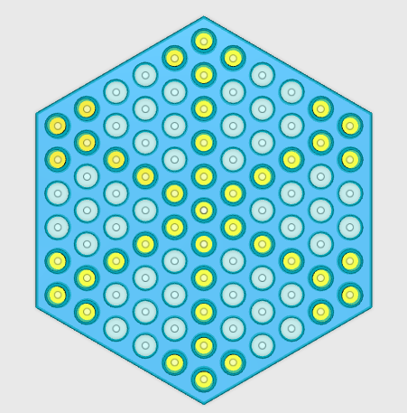
Fig. 1. Snowflake Picture (It’s a schematic diagram which shows one possible snowflake pattern.)

Type 2: LEDs could light 26 English characters and some simple words like “Hi”. Users can also compose long words by arranging more flashlights in a row.
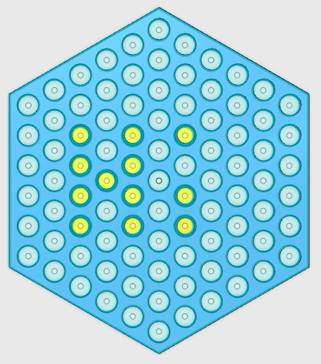
Fig. 2. Simple word picture of “Hi”

Type 3: “Weather Flag”. Our flashlight may have built-in figure representing different weathers. Choose one of these different weather flags to inform other people about the weather today. For example, choose a “sun” flag, it means that it’s sunny today. At the same time, the multi-color LED can light in different colors to imply the temperature. If it’s hot, it will light in red; if it is a little bit cool, it will light in blue, etc. And both the weather and the color of LED is selected by the user manualy.
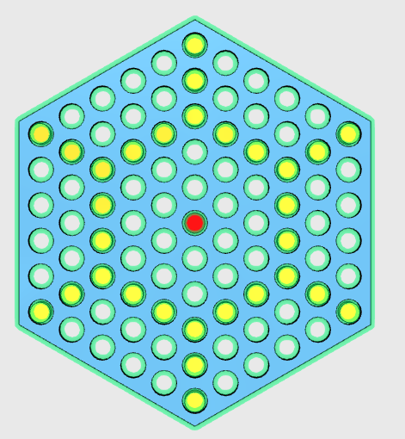
Fig. 3. Weather flag of sunny day and high temperature

b. As there are lots of LEDs laying on the hexagon, it will be a very clear sign for people to see. And our design is portable. Another function of MayFlower is designed to be a Code Transmitter. We use our LEDs to express some important signals through Morse code. For instance, it can express SOS by lighting all LEDs three times for 1 second and another three times for 0.5 seconds as a circle. Other codes can also be showed in similar way.

c. Timer function. The LEDs can light similar to the appearance of clock. LEDs at the edge of hexagon will light one by one until the LEDs of the first round of hexagon all lighted (may be per min) Then the second round will lit the same way as the first round .This step will keep going if there is still some LEDs unlighted. Once all LEDs are lighted, they will go off together and run the steps above again as a cycle. The central color-LED will play the role of a counter to tell how many circles have already been done. The figure 4 below is the simulation steps.
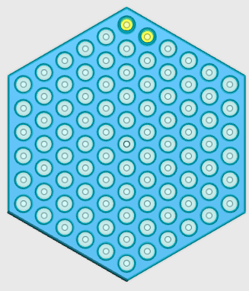
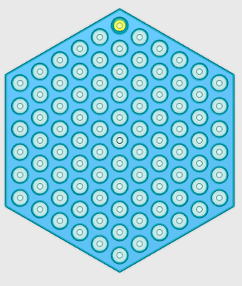
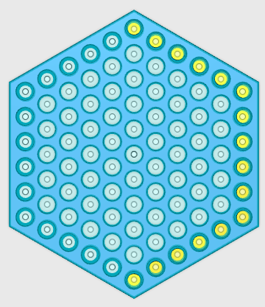
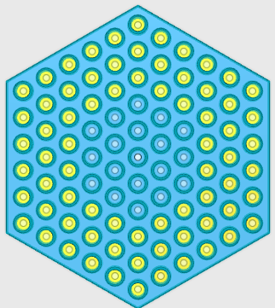
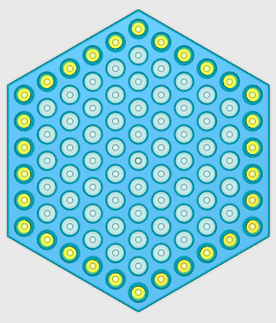
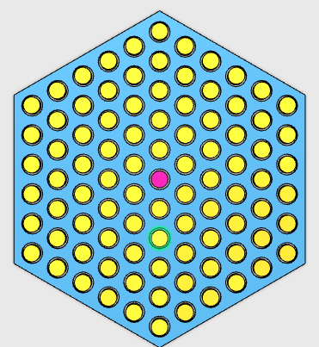
Fig. 4. The lighting sequence of timer

d. As the regular hexagon is center-symmetric, we find that our MayFlower can take advantage of this physical property to rotate around the central axis. We can imagine that a rotating LED flashlight is definitely much more attractive than an immobile LED flashlight. To accomplish this idea, a smooth hollow rod can be assembled at the center as the rotating axis so that the flashlight will not only rotate around the rod but also can be easily attached to the wall or some other surfaces through the hollow part.

Criteria for judging the ideas & Decision Matrix
We follow the instruction of choosing the most attractive one among the four ideas by using decision matrix. Each member of our team graded each criterion individually, after which we compute the average number for every criterion using these grades and fill in the decision matrix. The table 1 shows the entire criterion we used and their descriptions. And the weight of each criterion is decided by our discussion of which standard is much more important and which one is less signifigent.The table 2 is the decision matrix.

Criteria | Weight | Description
Appearance | 15 | The way that it may look.
Functional | 13 | Capable of operative
Impressive | 15 | The ability of evoking admiration
Design Difficulty | 12 | How difficult the idea will be implemented
Practical | 14 | How useful it is
Battery Life | 5 | How long will the battery last
Creative | 15 | The state or quality of being creative.
UPI | 7 | User Product Interaction
Emotional Value | 10 | Whether warm or not it may be felt
Flexible | 6 | Multi-application
Table 1. Criteria list plus the weight and description of each one

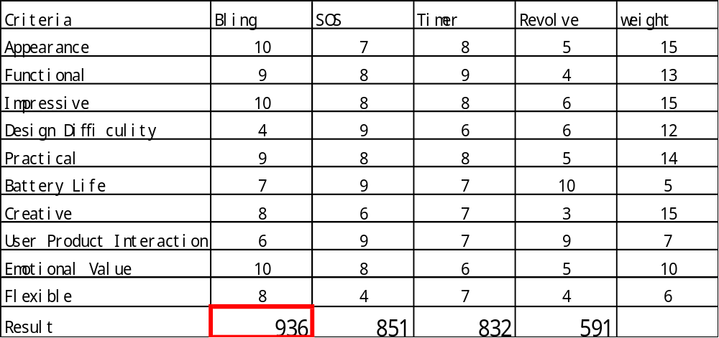Table 2. Decision Matrix

Conclusion:
Using the decision matrix with ten criterions, we can get the best design “Bling Bling Mode”. The “Bling Bling Mode” is advanced in the appearance, creativity and practicability. It is also a humanized product with high emotional value. We hope it can be one of the most popular accessories on the Christmas Eve. Thank Jing for writing the introduction and conclusion, Bolin for detailed elaboration of the ideas, Chengzhang for clear sketches and Yinan for editing the whole report.

